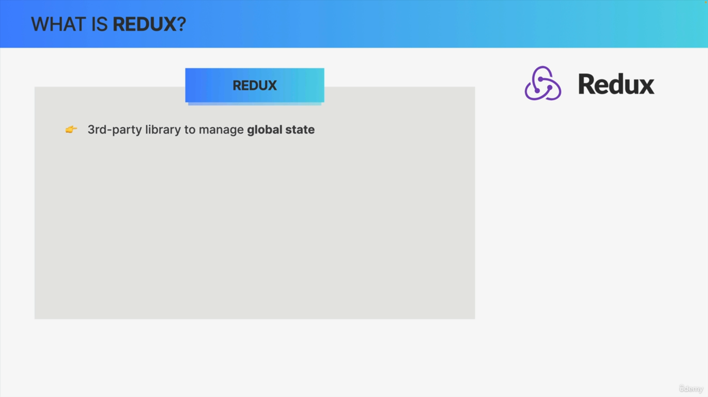

Redux is a third-party library that we can use to manage global state in a web application.

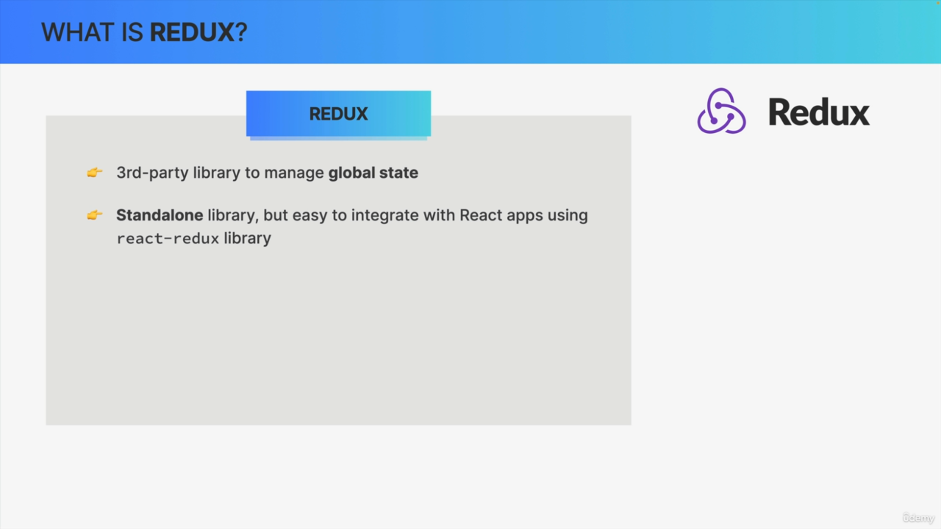

Because Redux is actually a complete standalone library that we could use with any framework or even Vanilla JavaScript but Redux has always been tightly linked to React and they are actually quite easy to connect using the react-redux library.

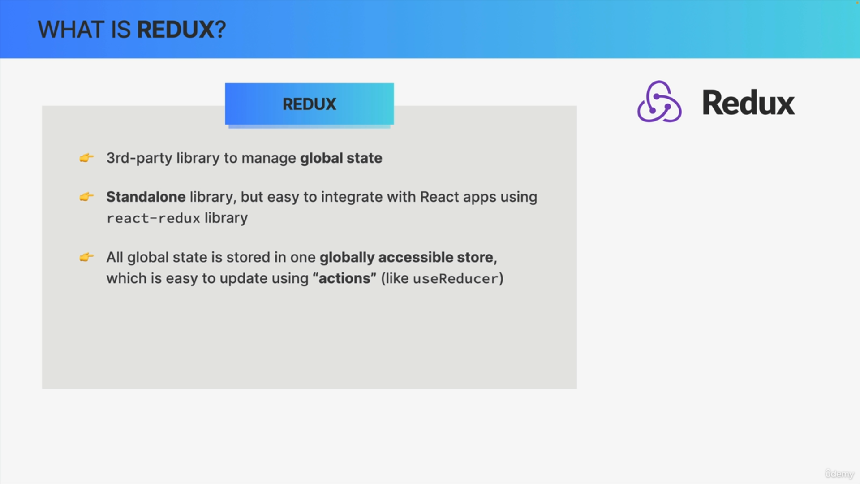

The big idea behind Redux is that all the global state in your application can be stored inside this one globally accessible store which we can then update using actions.

This sounds familiar, it's because the useReducer hook implements a very similar pattern. So, updating state by dispatching actions.

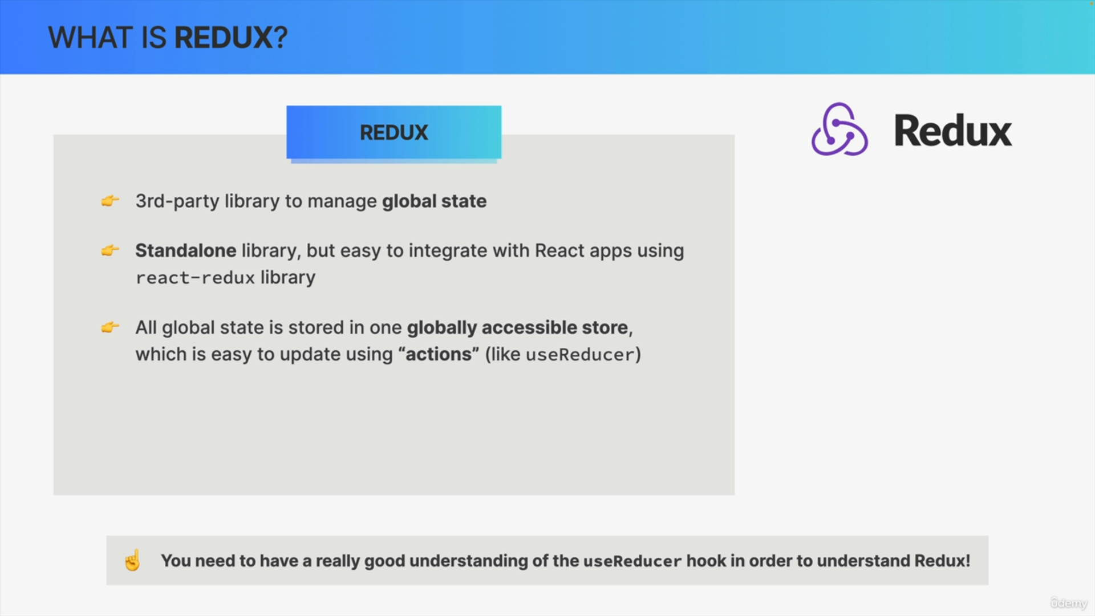

The idea of updating state in React and in Redux is always the same.

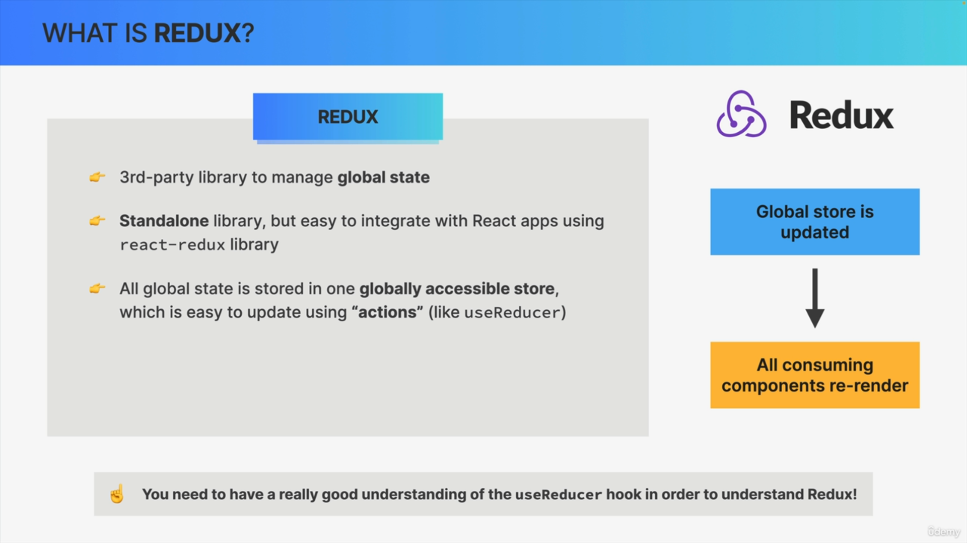

So, in the case of Redux, as soon as we update the store all the React components that consume some data from the store will be re-rendered.

So, conceptually, if we think about this Redux is actually quite similar to combining the Context API with the useReducer hook as we have done in the World Wise app.

In fact, many developers even say that the Context API is a replacement for Redux.

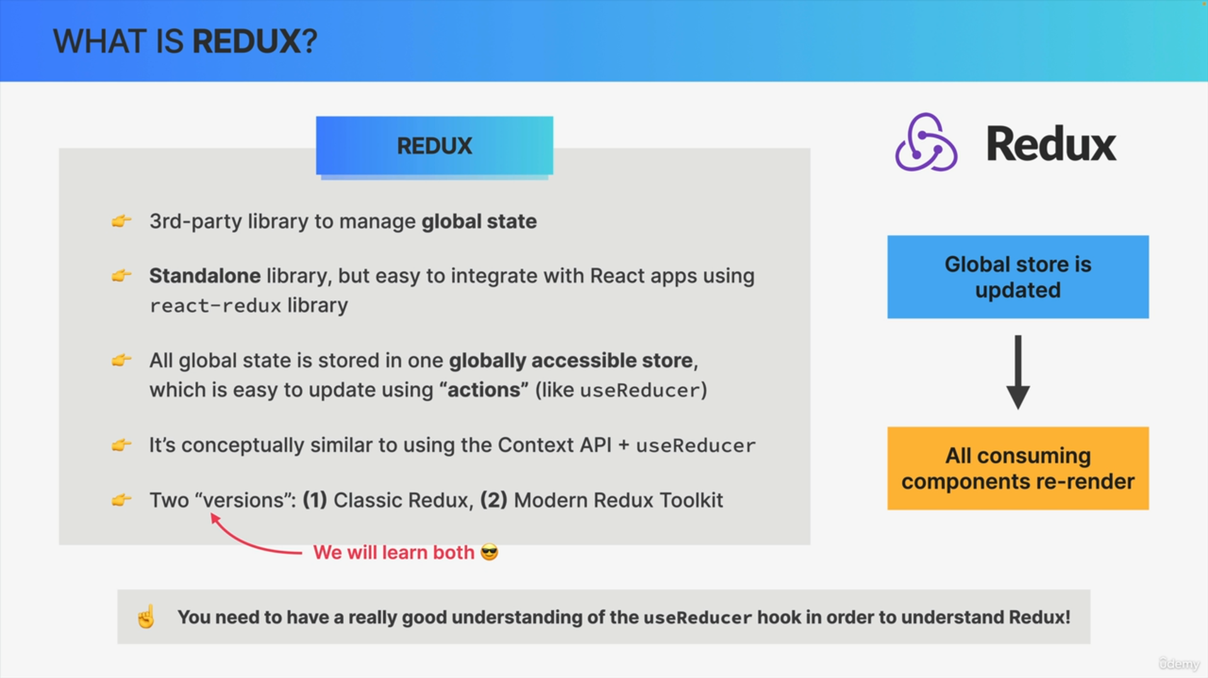

Redux has a long history and there are basically two versions of Redux.

So, two different ways of writing Redux applications, but which are totally compatible with each other.

So, we have the classic Redux and we have the more modern way of writing Redux with Redux Toolkit.

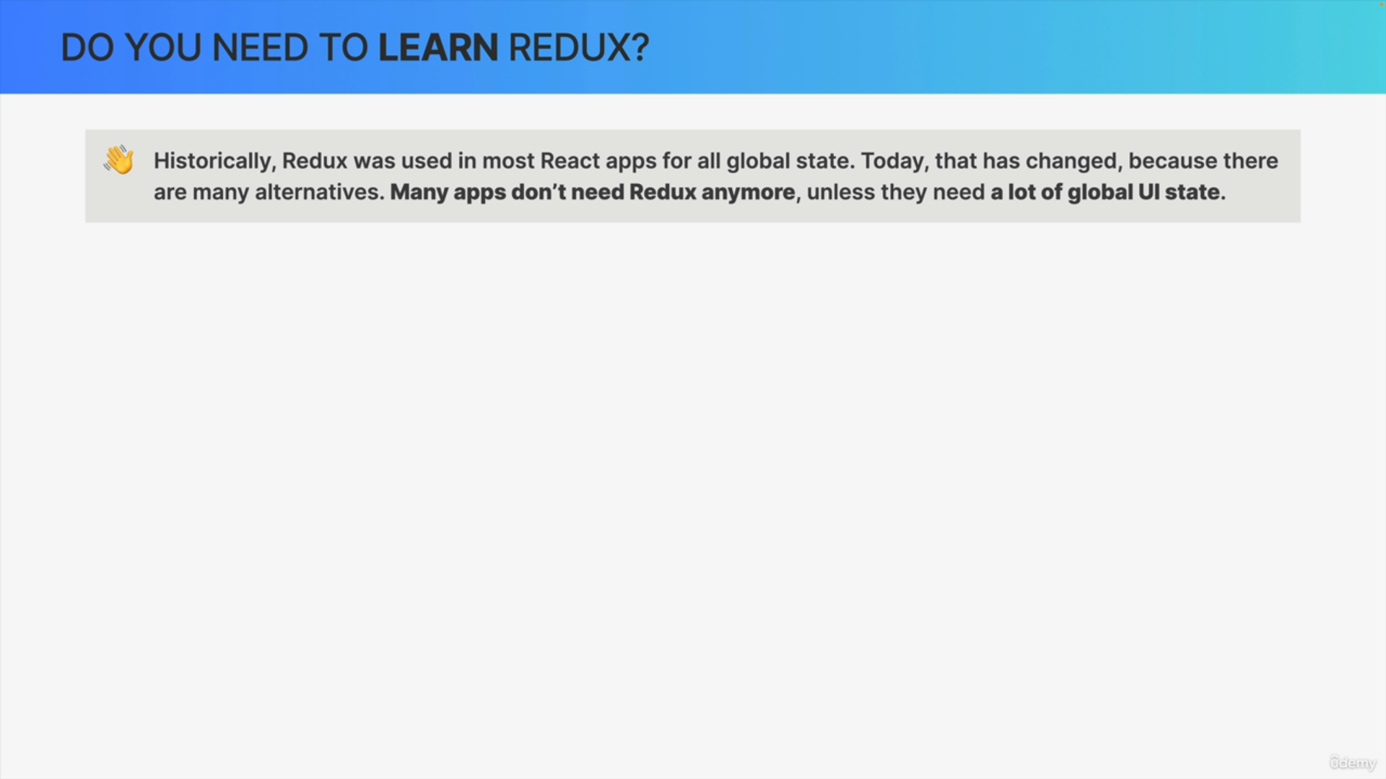

So historically, a few years back, Redux was used in almost every React app out there for all global state management needs.

It was as if Redux was even part of React.

Today, however the landscape has changed tremendously, because there are now many alternatives of state management.

So today, many apps don't actually need Redux anymore and also don't use Redux anymore and this means that you might not even need to learn Redux right now.

So why is it included?

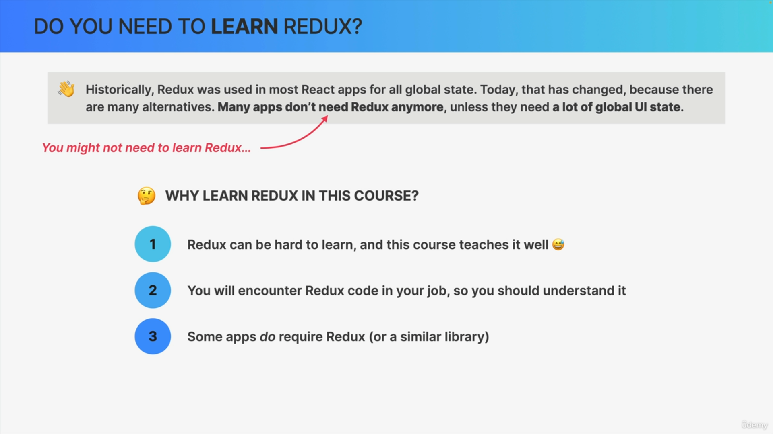

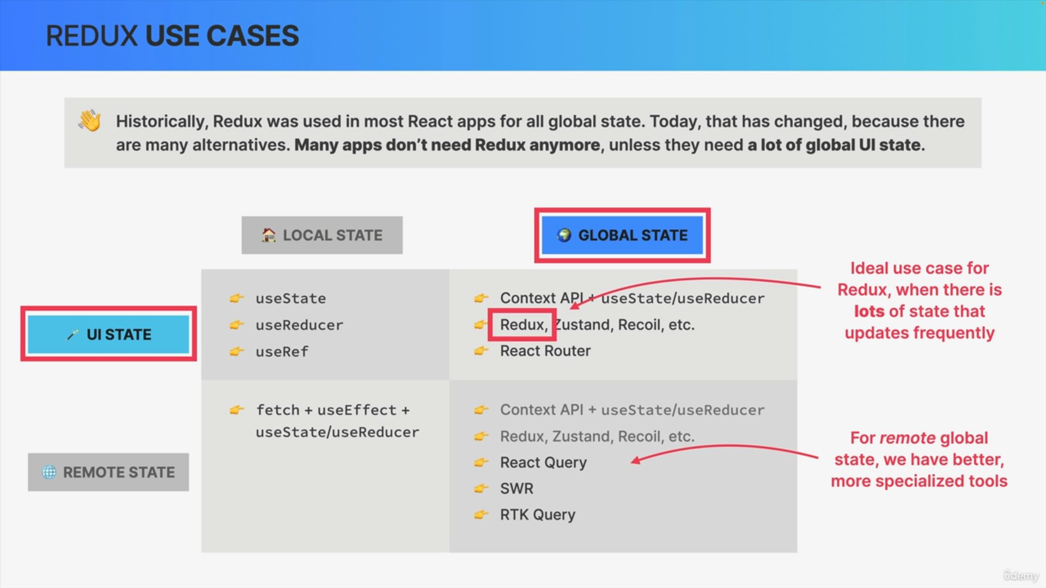

The recommendation of many experts is to use a global state management library like Redux, only when you have lots of global UI state that you need to update frequently.

UI state basically means state that is not fetched from a server that would be remote state. So, UI state is simply data about the UI itself

or data that doesn't need to be communicated to an API or so.

This distinction is really important, because remember for global remote state we have many better options nowadays like React Query, SWR, or even a tool that is kind of included in modern Redux Toolkit, which is Redux Toolkit Query.

So, when you need to manage a lot of non-remote state in your app, then Redux might be perfect for that.

But the truth is that most global state is actually remote which is the reason why so many apps don't use Redux anymore.

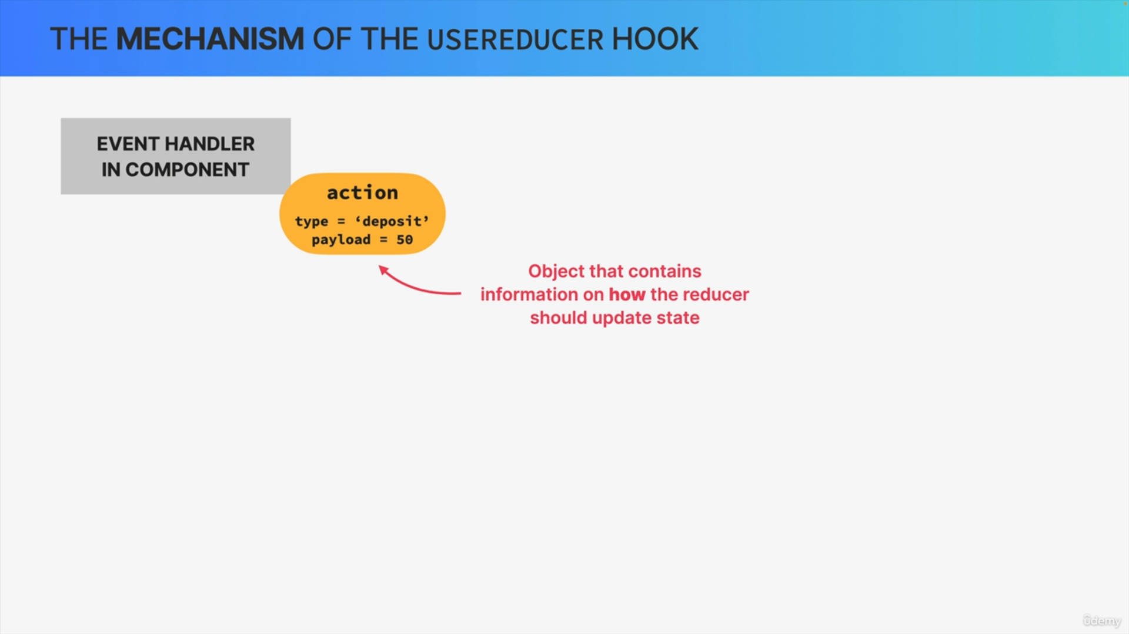

With useReducer when we want to update state from an event handler in a component, we start by creating an action. This action is simply an object that usually contains a type and a payload, which is information about how the state should be updated.

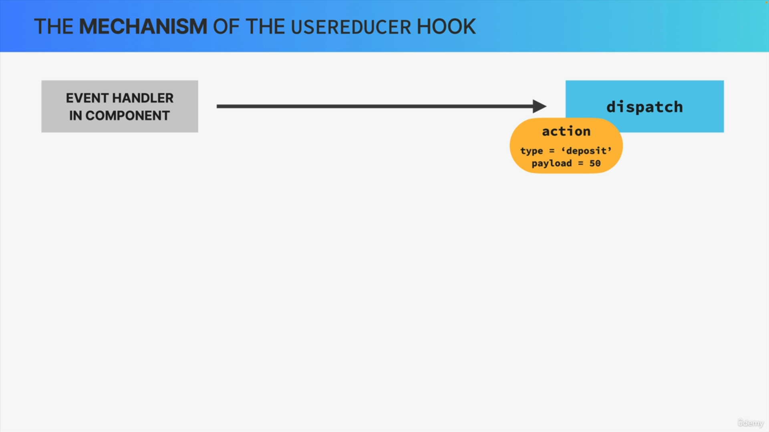

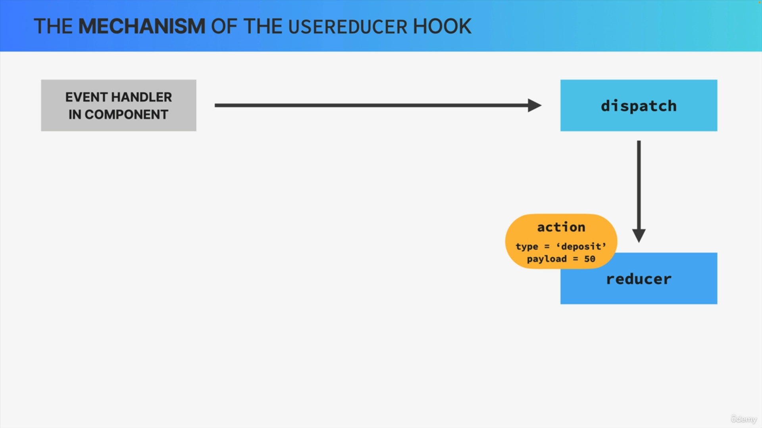

We then dispatch that action to a so-called reducer function.

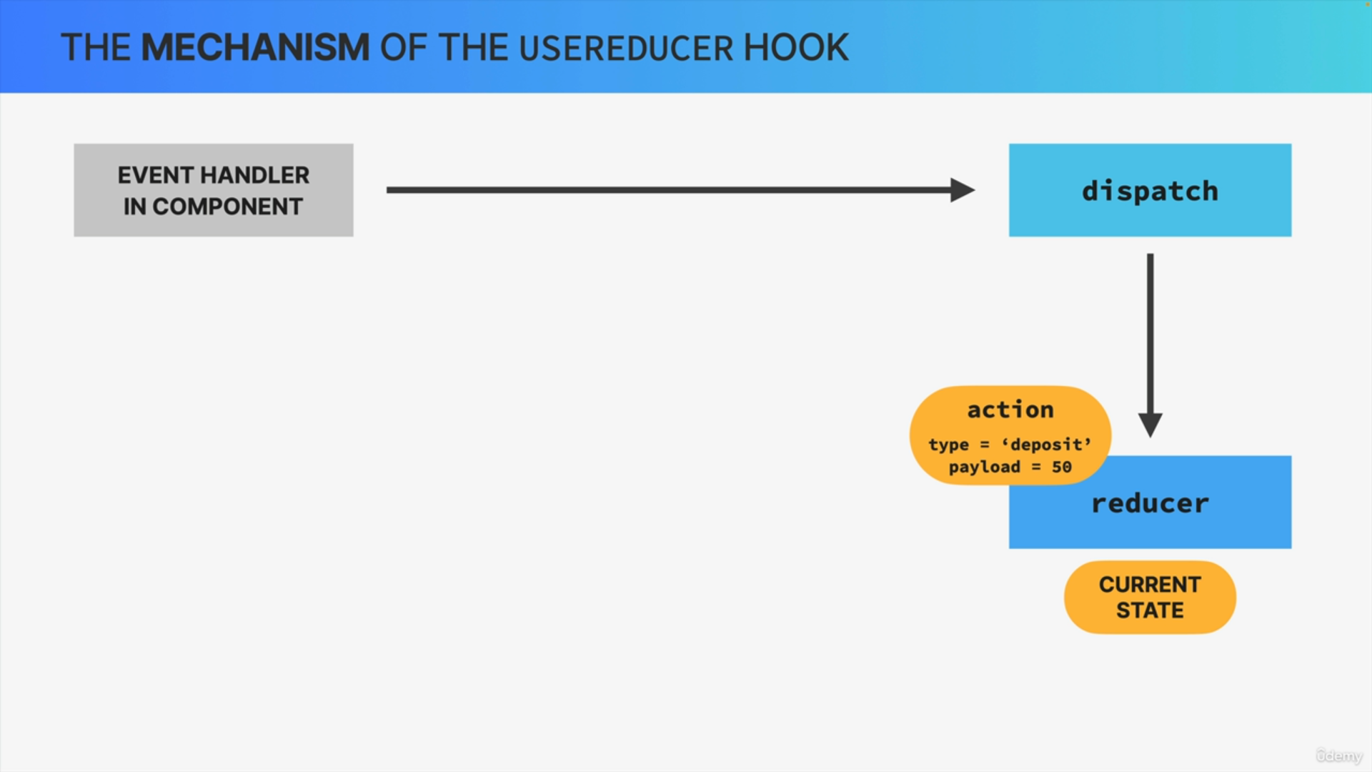

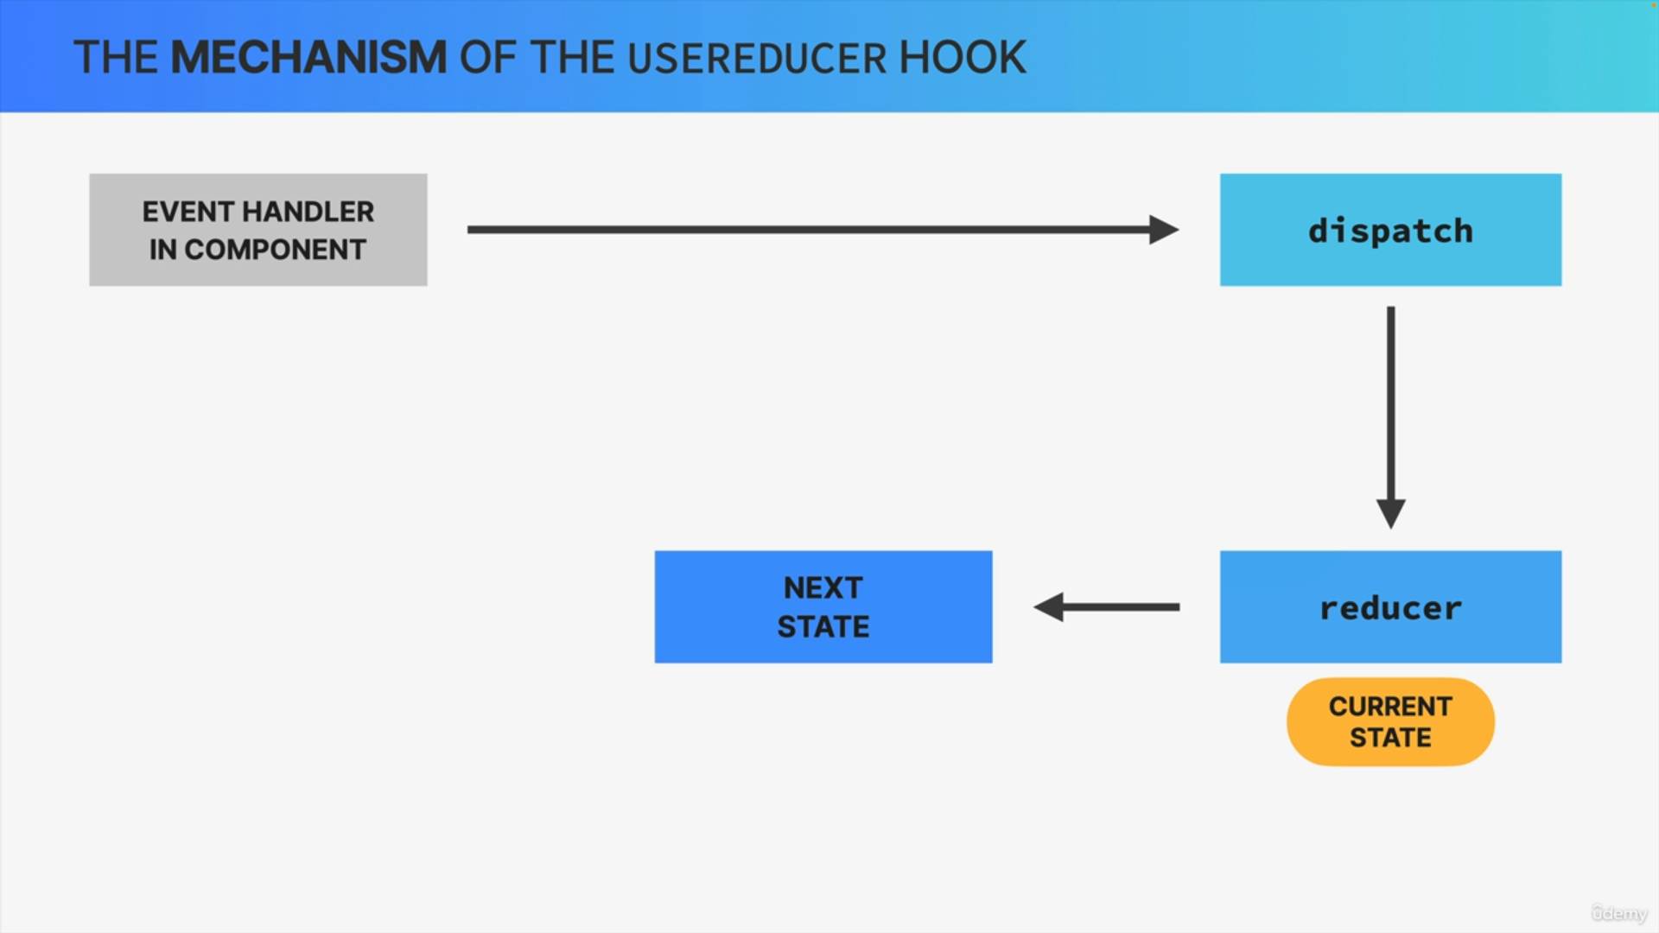

The reducer takes the action type and the payload, and together with the current state calculates the next state, so the new state value.

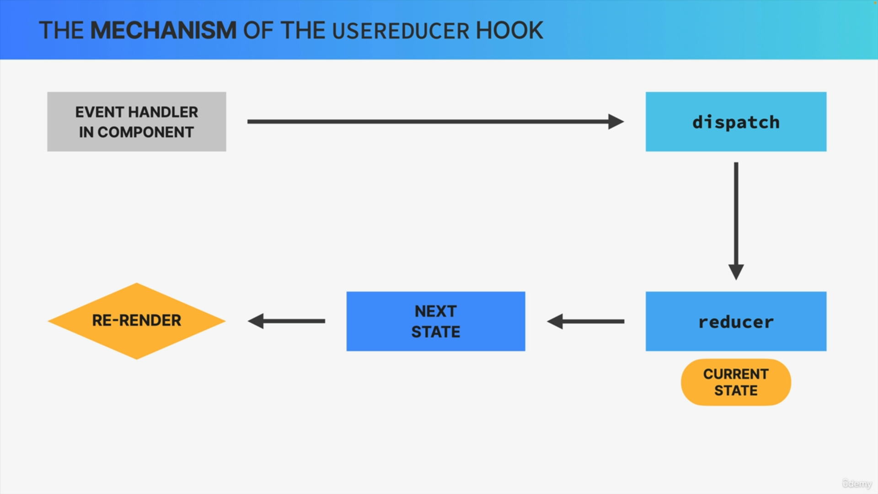

To finish as the state updates, the component that originated the state transition will re-render.

So this mechanism should be familiar to you at this point, because now we're gonna add two more things onto this in order to learn how Redux works.

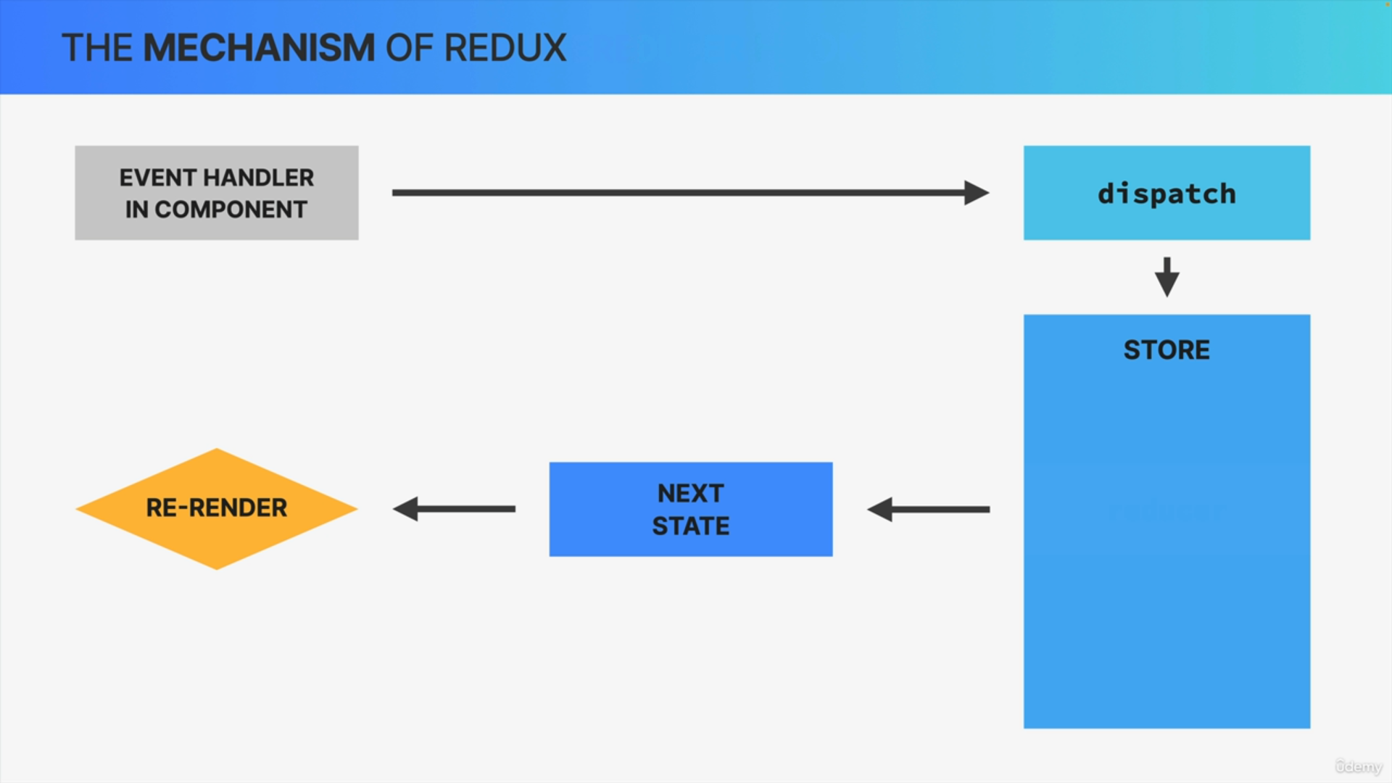

So, the first difference between useReducer and Redux is that in Redux we actually dispatch actions not simply to the reducer.

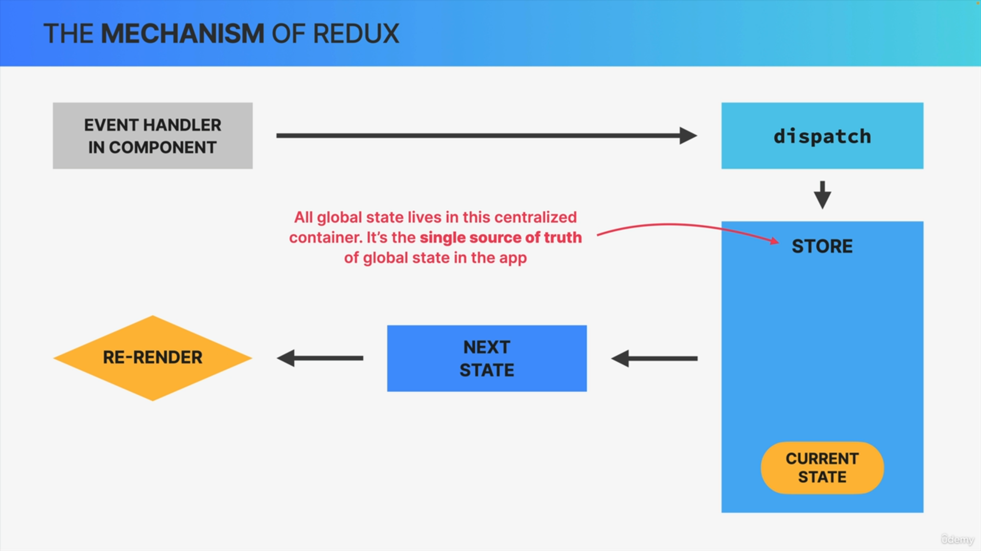

So, this store is a centralized container where all global state lives. It's like the single source of truth of all global state across the entire application.

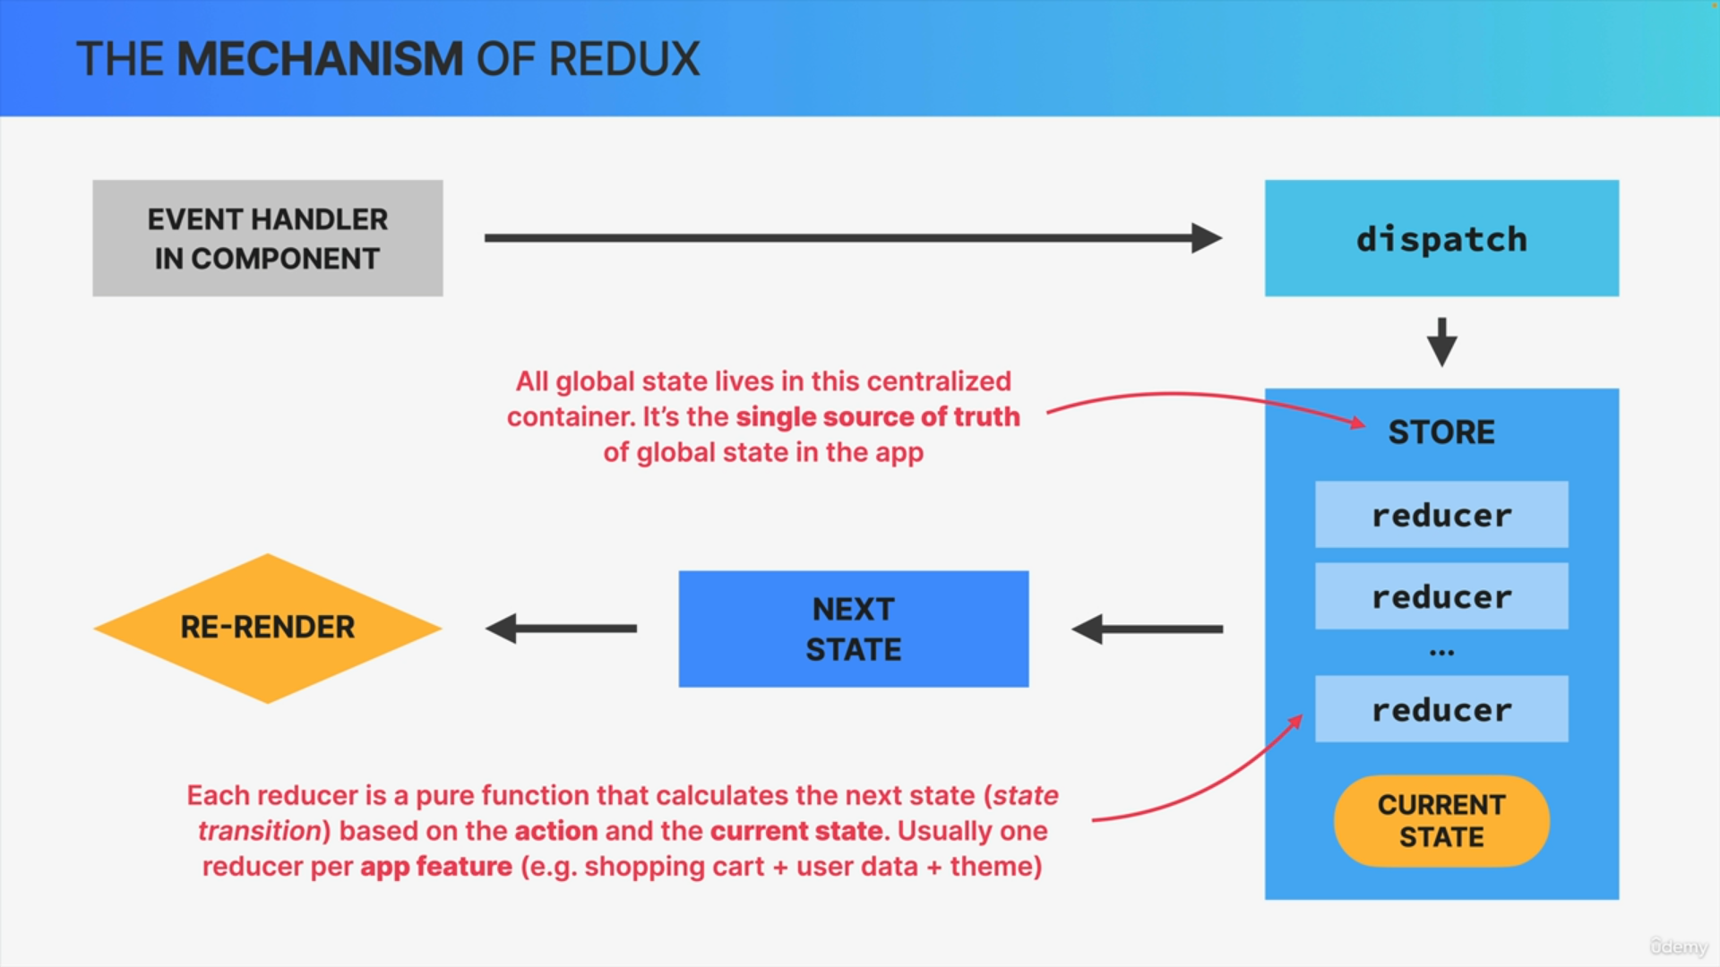

The store is also where one or multiple reducers live and each reducer must be a pure function that has the single task of calculating the next state based on the action that was dispatched to the store and the current state that's already in the store as well.

Now, you might be wondering why there are multiple reducers in this store.

Well, it's because we should create one reducer per application feature or per data domain in order to keep things separated. For example, in a shopping app, you could have one reducer for the shopping cart, one for some user data, and one for the application color theme.

Finally, any component that consumes the state that has been updated in the store will as always get re-rendered by React.

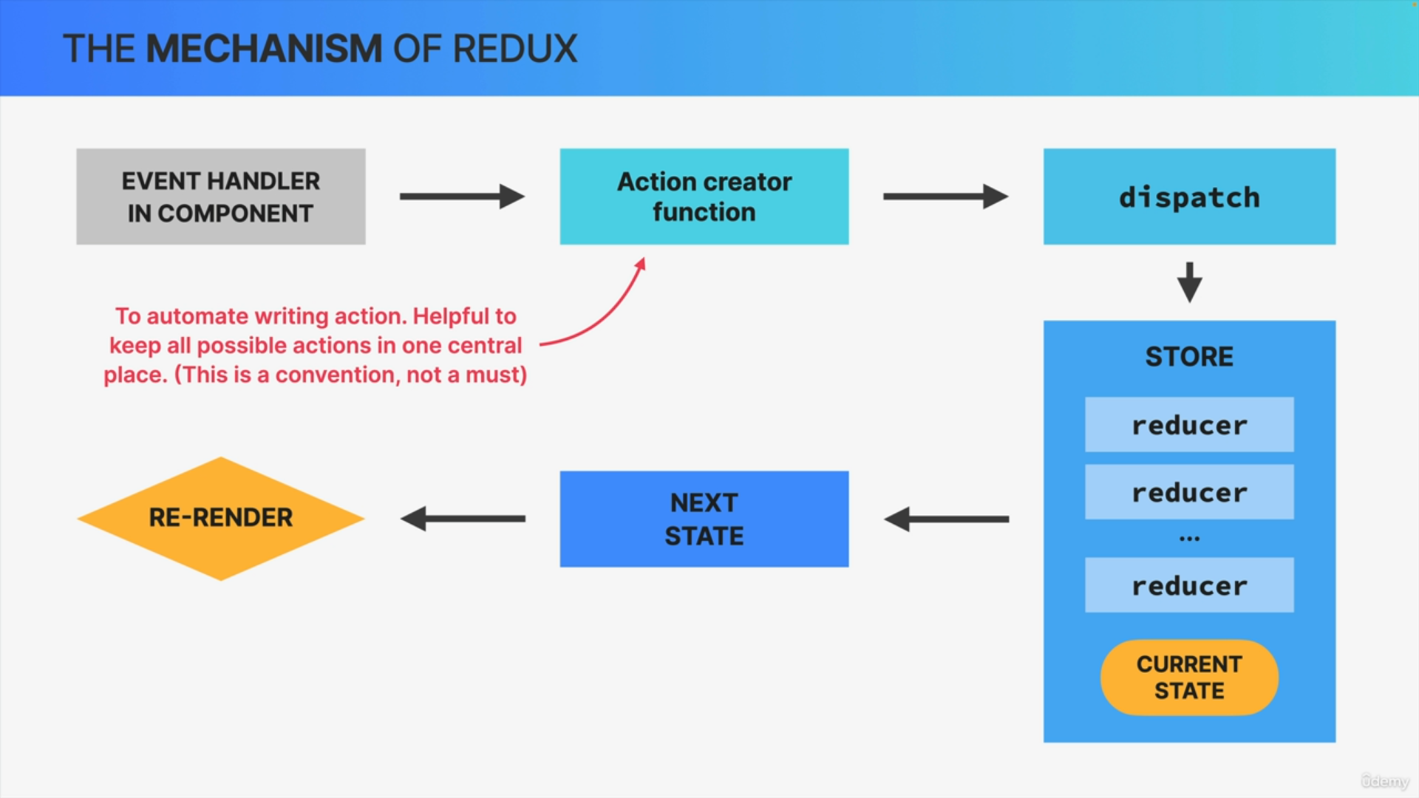

So, in the real world when we use Redux, we usually use functions called action creators in order to automate the process of writing actions.

So, basically, instead of always writing these action objects by hand, we create functions that do this automatically.

This has the advantage to keep all actions in one central place which reduces bugs, because developers don't have to remember the exact action type strings.

Just note that this is optional and not a feature of Redux. It's just how we build real world Redux apps.

The big goal of all this is to make the state update logic separate from the rest of the application.